Ideas for AI agents
What if you could turn a generative AI tool into your own team of experts, ready to help you take on any challenge? What if they were speedy, creative, and able to roleplay through all kinds of scenarios to help you with work? Well, there’s no “what if” required—that’s what an AI agent is designed to do. You can create an AI agent to help you with whatever you need, from writing a speech to learning about coding. Here, you’ll learn how to craft your own and start working smarter.
Design AI agents
To create an agent, you’ll prompt the gen AI tool as you usually would, following the prompting framework, but you’ll focus on persona and context more than ever. The more detail you include about what you want the AI agent to do, and how you want it to respond, the more effective it will be.
Here’s how to create an AI agent:
- Assign the persona you want the gen AI tool to take on. Example: “Act like a successful personal fitness trainer and talented nutritionist.”
- Give context and details about the scenario and conversation. Example: “I’m looking to improve my overall fitness and adopt a healthier lifestyle.”
- Specify conversation types or the kinds of interaction you want the tool to support, and set some “rules” for the AI agent to follow. Example: “Ask me about my workout routines and meal planning and give me feedback.”
- Provide a stop phrase you can use to end the conversation. Example: “When I want the conversation to end, I’ll write, ‘no pain, no gain.’”
- Ask the tool to provide takeaways or improvement areas after the conversation ends. Example: “At the end of our conversation, provide a summary of the advice you provided.”
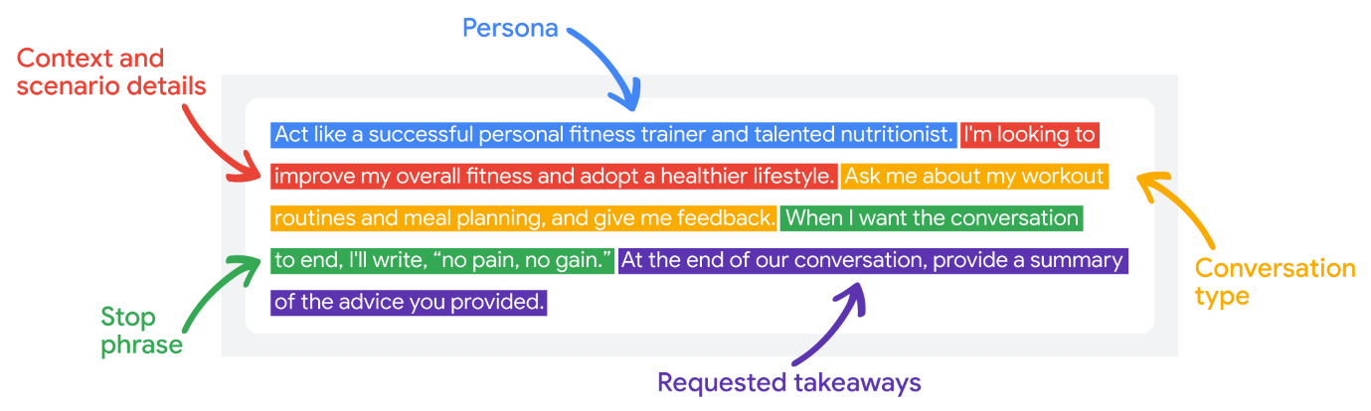
AI agent applications
You know what goes into a prompt to create an AI agent, and earlier, you learned about two examples of how to use them: AgentSim and AgentX. Now, you’ll uncover a couple more situations for AI agents that you might find really useful at work or in your personal life. But just so you know, these are only a few of the ways an AI agent can help you out! Because AI agents simulate conversations and are capable of roleplaying, they’re great for a ton of different scenarios.
Practice skills
Have you ever wanted to improve your public speaking skills? Or practice a difficult conversation you’re planning to have? AI agents can help by acting as a digital coach that can give you feedback on a wide range of scenarios, and build your skills in the process.
Consider this one: you’re a freelance web developer looking to improve your negotiation skills to close more deals, build stronger relationships, and lock in better rates and terms. You can create an AI agent that takes on the persona of a seasoned negotiator and business consultant to help you do just that. To practice a skill with an AI agent, add in a lot of context about the expertise you're honing, and be specific about what it can do to help you achieve your goals.
Here’s an example:
I’m a freelance web developer. I want to brush up on my negotiation skills so I can demand higher rates, establish clear project boundaries, and create mutually beneficial relationships with my clients. Take on the persona of a seasoned business consultant with serious expertise in negotiation strategies for freelance web developers. I’d like you to assess and improve my negotiation skills by roleplaying with me through example negotiation scenarios that I might encounter at work and practical exercises, providing industry-specific advice and feedback as I respond. When I want to end the roleplay, I’ll write “I’m finished.” When our conversation is over, provide me with a list of personalized, actionable ways I can improve my negotiation skills.
Get specific feedback
An AI agent can give you suggestions and recommendations for a particular task. For example, you can create an AI agent that takes on the persona of an editor and helps you change or improve a piece of your writing and provides feedback on your style, format, tone, and more.
Suppose you want to submit a piece of writing to a magazine. Before you submit it, an AI agent can provide critiques and suggestions. To receive feedback on a writing piece, paste your work into your prompt and get specific about your desired outcome, the context, and the persona you want the tool to take on. Note that depending on how much text you want to include in your input (how long of a document you need critiqued), you might need a gen AI tool with a long context window, which allows for the processing of a large amount of information in different formats at once. With that in mind, you could craft a prompt like this:
I’m submitting a creative writing piece to a literary magazine for a prize. The magazine is known for its fantasy and sci-fi content. The judges are accomplished fantasy writers and will be choosing a winner based on worldbuilding, originality, and technical skill.
Take on the persona of one of the magazine’s judges and critique my piece through the lens of those key areas. Provide suggestions for changes and improvements to further meet the competition criteria.
The stop phrase will be “I’m ready to submit.”
Attached are the submission and judging guidelines, a reference piece that won the prize last year, and my story: [upload documents].
Learn something new
An AI agent can help you learn more about an unfamiliar topic or even help you learn a whole new skill by taking on the persona of an expert.
Imagine you have Spanish-speaking clients who prefer to communicate in Spanish. You don’t know the language, but you want to learn so you can build more of a rapport and collaborate more closely with them on your projects. An AI agent can help you learn the language by taking on the persona of a Spanish tutor who delivers increasingly difficult lessons, crafts activities and scenarios, chats with you in Spanish, quizzes you, provides feedback based on your responses, and even gives you a little bit of homework. To learn something new, write a prompt that includes a lot of information and detail about what you want the AI agent to do for you.
I'm trying to learn Spanish to better communicate with my clients who live in Guatemala. Take on the persona of a skilled Spanish tutor and help me learn Spanish. I want you to teach me Spanish by delivering increasingly difficult lessons, crafting educational activities and scenarios, chatting with me in Spanish, and quizzing me. Correct my errors when I respond and call out areas of improvement. Provide feedback in English only. When I want to end the lesson, I'll write "adios." After we finish our conversation, provide me with a personalized list of vocabulary words, conjugations, and tips I should study to become a better Spanish speaker.
Collaborate on a project
While AI agents are great at helping with broad goals and tasks, they’re also great at honing in on super specific items you need to cross off your to-do list.
Pretend you’re a city planning researcher looking for some additional funding for a new project. If you create an AI agent that takes on the persona of a grant writer and give it information about the grant by providing a link or uploading an image of it, you can have it act as your partner to help you complete the proposal based on the grant’s requirements and evaluation criteria. Provide the context, specify the persona, and add as much detail as possible for what you want to achieve, like this:
I’m a city planning researcher seeking a grant for a revitalization project. I need assistance crafting a compelling and competitive grant proposal. Take on the persona of an experienced grant writer with expertise in revitalization grants and act as my collaborative partner. Let’s work together on the proposal, brainstorming ideas, refining the language, and ensuring it aligns with the grant’s requirements and evaluation criteria. We’ll focus on developing the following key components:
- Project Summary: A concise and engaging overview of the project's purpose, goals, and expected outcomes
- Project Description: A detailed explanation of the project's activities, methodology, and timeline
- Budget breakdown: A comprehensive and itemized budget, justifying each expense and demonstrating financial responsibility
As I write each section with you, provide insights for how to strengthen them, making sure my work is clear, persuasive, and impactful. The goal is for the proposal to align with the funder’s priorities and showcase the project’s potential for significant impact. When I want to end our session, I’ll write “We’re done.” After our conversation ends, provide a list of takeaways and learnings from our working session that I can consider next time I write a revitalization grant.
Here is information about the grant and its evaluation criteria: [upload document].
More AI agent ideas
These are only a few ways you can utilize gen AI tools to build AI agents to accomplish your goals. For more ideas on how best to use AI agents, check out the following resources:
- Professor Ethan Mollick’s newsletter, One Useful Thing: While not solely focused on AI agents, this newsletter does feature practical gen AI tips and prompts, as well as research-based insights and thought-provoking discussions on how AI is transforming different areas of our lives.
- Langchain: This is a popular open source framework that uses low code or no code to string AI agents together to accomplish tasks.
- Google Vertex AI Agents: These allow users to design and integrate a conversational user interface into their mobile apps, web applications, devices, bots, interactive voice response systems, and more. They can analyze multiple types of input from customers, including text or audio inputs (like from a phone or voice recording), and respond through text or with synthetic speech. Using Vertex AI Agents, users can provide new and engaging ways for people to interact with their product.
- Gems: These are customizable AI personas you create within Gemini, each with specific skills and knowledge, that are ready to assist you with specific tasks or delve into any topic you’re interested in. A specific feature built into Gemini, they provide a structured way to create and manage AI agents. There are a few premade Gems you can work with, including a learning coach, brainstormer, career guide, writing editor, and coding partner.
An AI agent can act as your trusty sidekick across all kinds of use cases. They’re not just here to make things fun (though they certainly do that), they’re also powerful tools to help you level up at work and in day-to-day life. Go ahead and give it a try—you might be surprised at what you can accomplish with the help of an AI agent.
- AI Agent:
An AI agent is a generative AI tool designed to assist users by simulating conversations and roleplaying scenarios tailored to specific tasks.
- Prompting Framework:
A structured approach to creating prompts that define the persona, context, and rules for the AI agent, enhancing its effectiveness.
- Persona:
The character or role that the AI agent adopts to interact with the user, which influences the style and type of responses it provides.
- Context:
The background information and details provided to the AI agent to guide its responses and interactions effectively.
- Roleplaying:
The ability of AI agents to simulate real-life scenarios and conversations, allowing users to practice skills and receive feedback.

